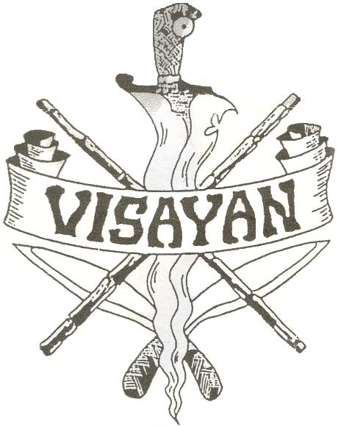
Visayan Style Corto Kadena

Eskrima

Double Stick Seminar

Discover the highly effective principles of doblecada developed by the late Eskrima master Sonny Umpad, including his unique center-line roll and efficient techniques for leveraging power, in the second-ever seminar presented by three of his senior Guros. With nearly 70 years combined experience, Chris Suboreau, George Yore and Mike Braten present the innovative style that first propelled Maestro Sonny to the attention of the martial arts world!

When: Sunday, December 03, 2006, 12-4 PM
Where: Fighting Arts, 3224 Grand Ave. Oakland, Ca.
Cost: $50 at the door Cash Only - Space Limited
Bring your own sticks (24” recommended)

For Further Information, contact

George Yore (spinesafe@access1.net)
Jeff Finder (stickman@stickman-escrima.com)

