SEMINAR

COMBAT ORIENTED FIGHTING ARTS

FILIPINO BOXING / CHINESE – INDONESIAN

Sponsored by

Jeff (Stickman) Finder

- FEATURING -

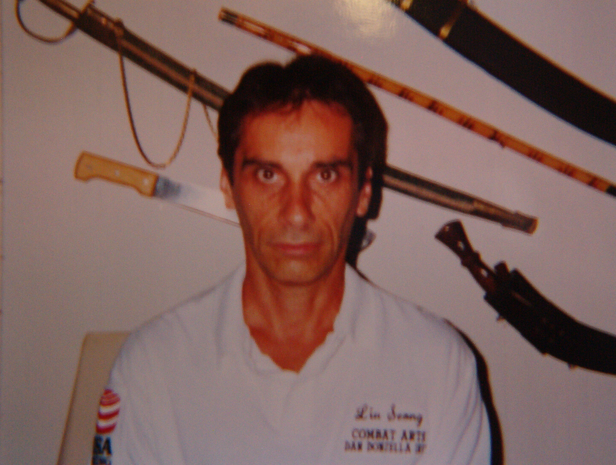

Sifu Guru Dan Donzella

Sifu Donzella began his martial arts training in 1973 studying the Chinese/Indonesian art of Chuan-fa /Tjimande under the Liu Seong family name. The system was founded by Great Grand Master Willem Reeders. At the age of 4, GGM Reeders began his training in the Chinese arts under his great uncle Leong Liu Seong, and later under many silat teachers as well as Nes de Vries of the Serak system. With a Chinese Indonesian base, Sifu Dan Donzella expanded his knowledge in these arts over the years as well as adding Arnis , the Filipino arts.
Sifu Donzella will be teaching Sumatran Harimau, (tiger ground fighting). Use of levers is well known in Pentjak Silat to over power your opponent with little effort.

Saturday April 12, 2008 2-5pm
Location- SUIGETSUKAN DOJO 103 INTERNATIONAL BLVD. OAKLAND, CA.
(510) 452-3941 $20. advance $25. Door (cash only please)

Contact info- Jeff “Stickman” Finder stickman@stickman-escrima.com (510) 222-0332

